**EX:NO : 9 CREATE & EDIT ARTICLES, MENUS USING DRUPAL TOOL**

**DATE : 01/02/25**

**AIM:**

To create and edit articles, menus using Drupal tool.

**PROCEDURE:**

**STEP 1:** Create an article in drupal.

**STEP 2:** Add text and images to the article.

**STEP 3:** Create a menu in drupal.

**STEP 4:** Give title for the menu and the url/link for the menu.

**STEP 5:** View the article & the menu created.

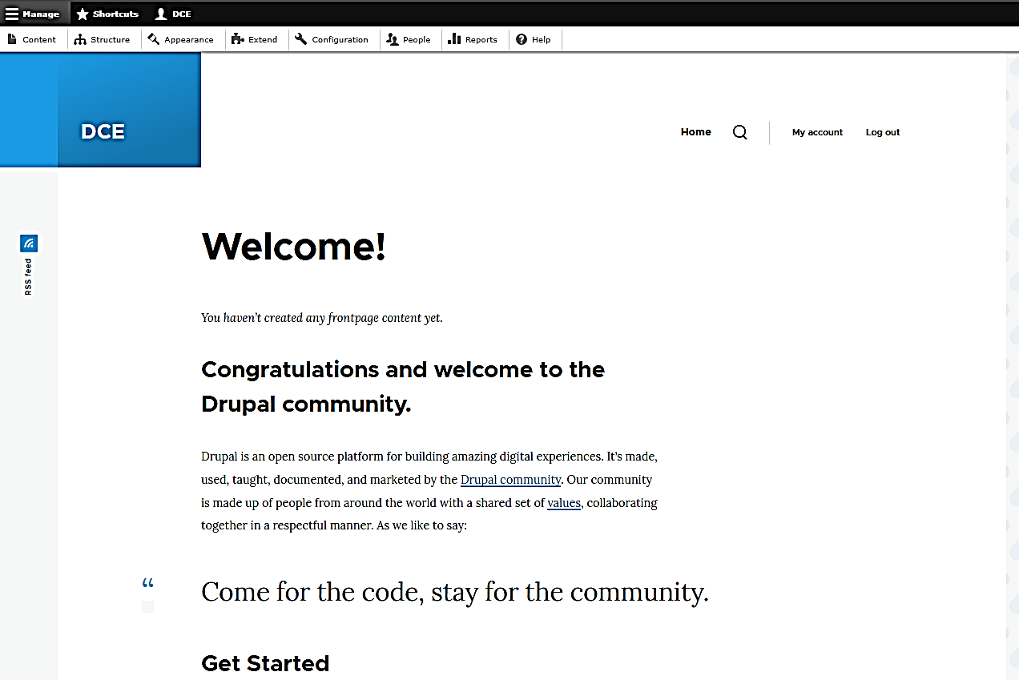

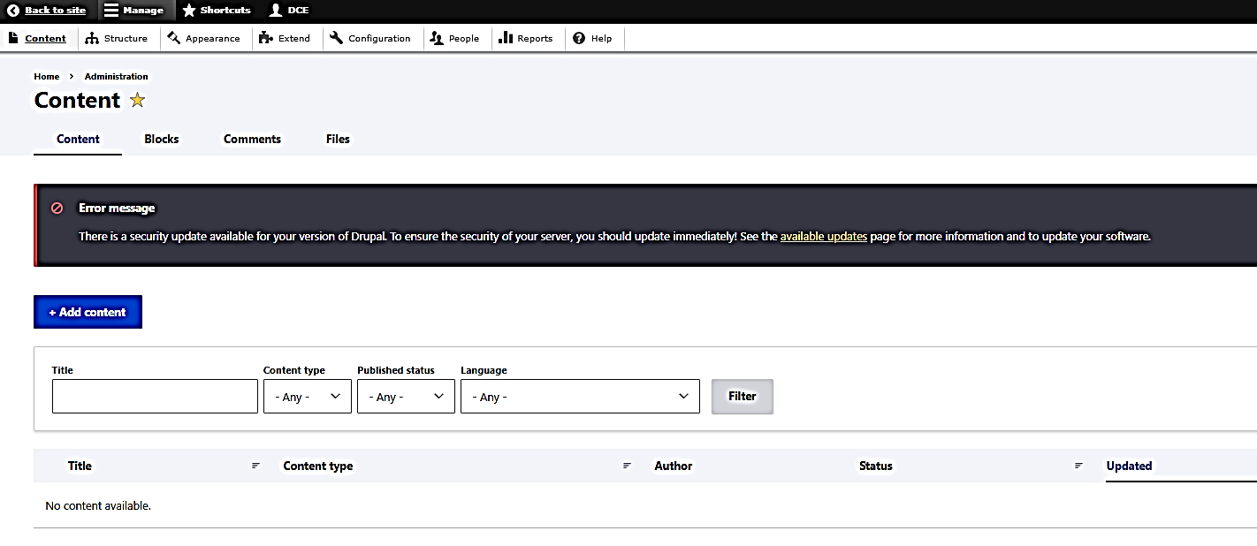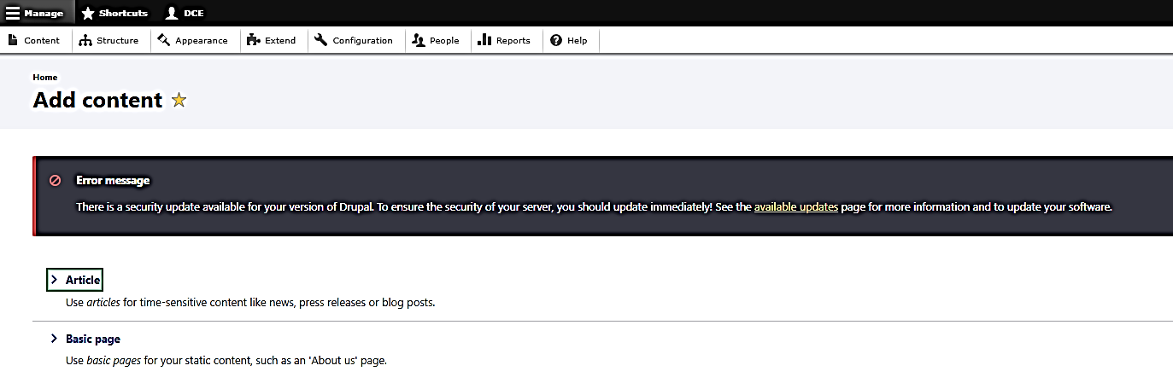

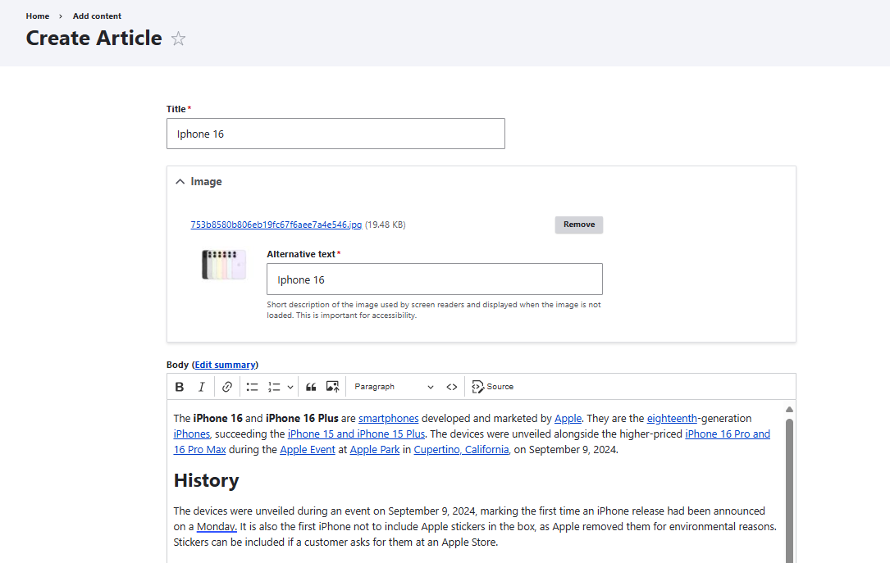

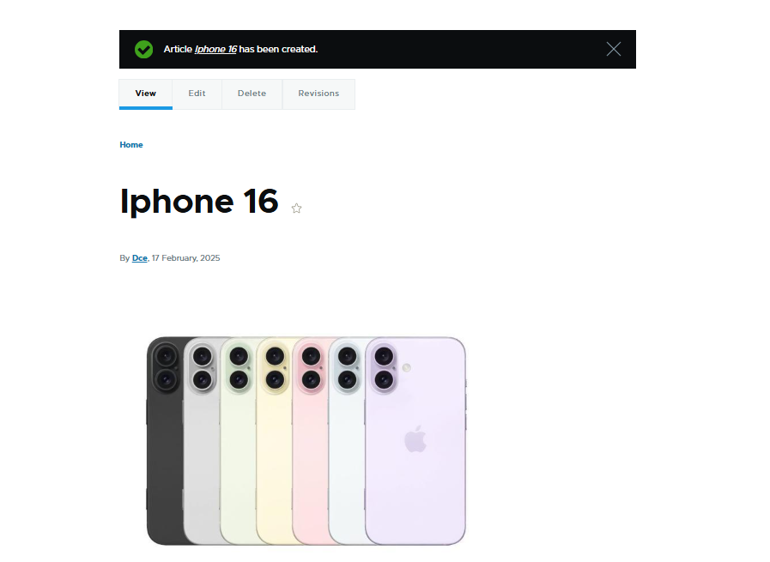

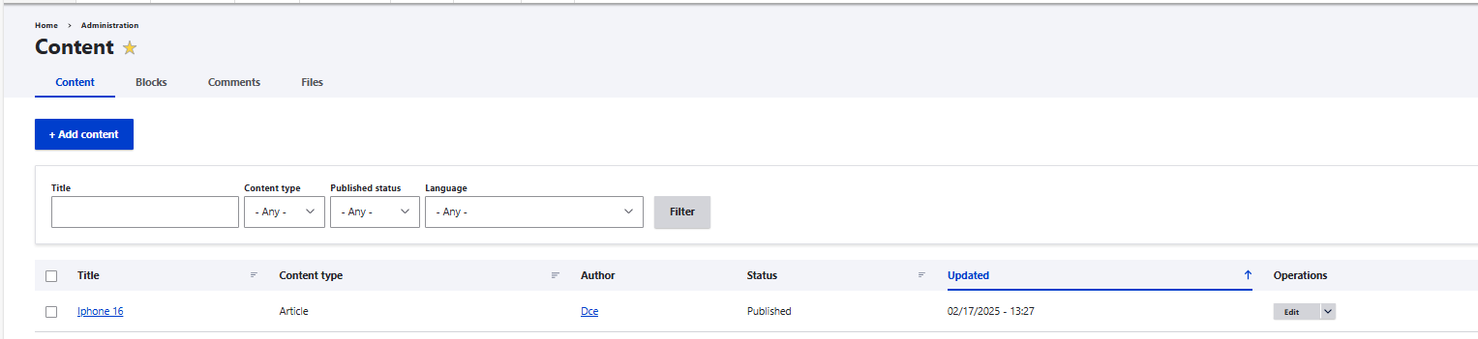

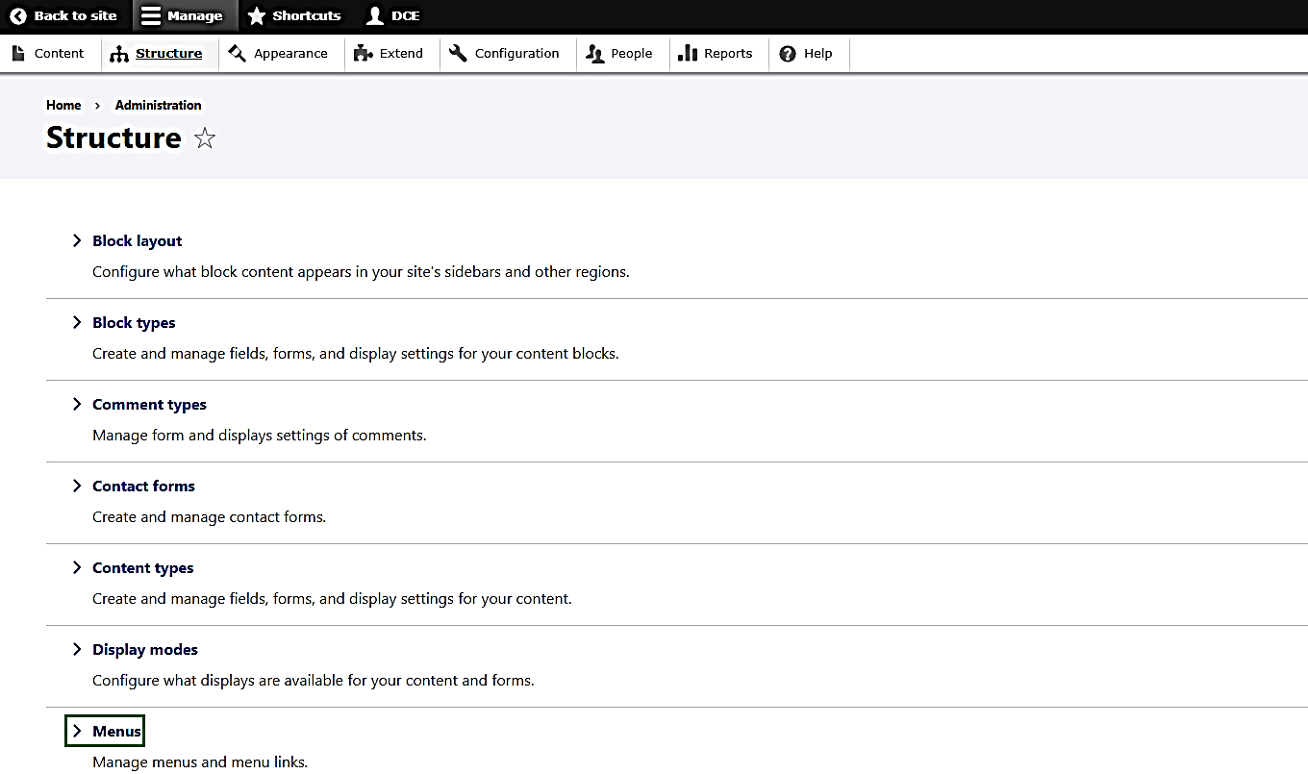

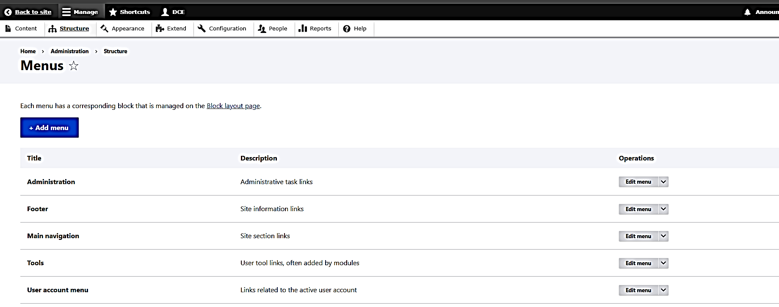

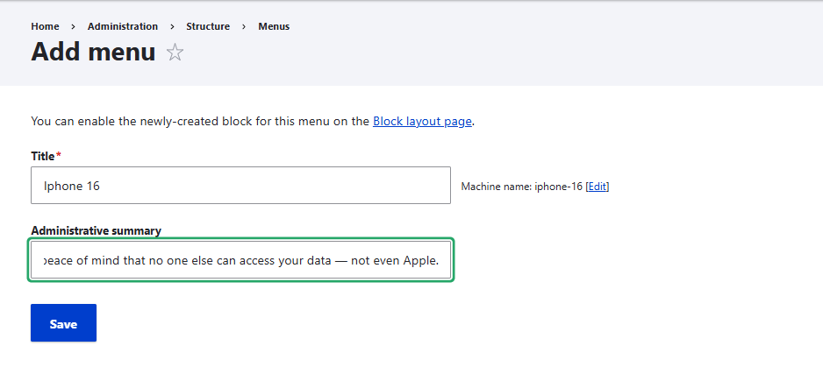

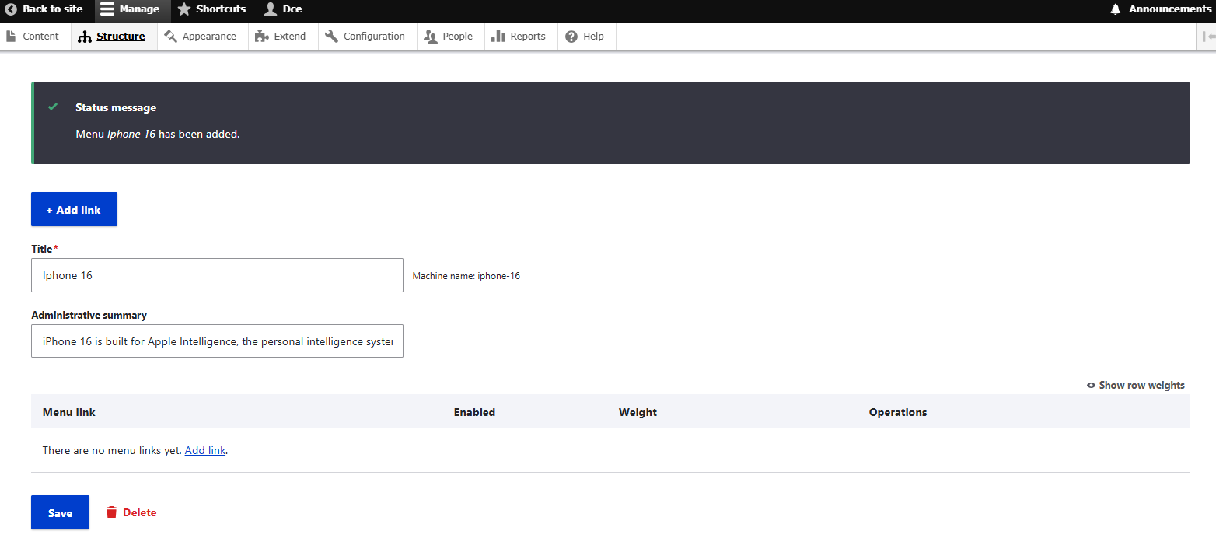

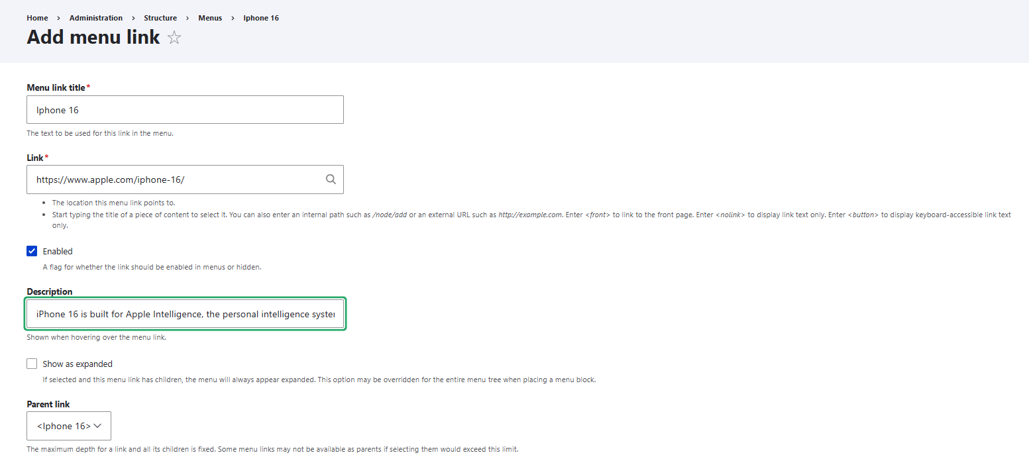

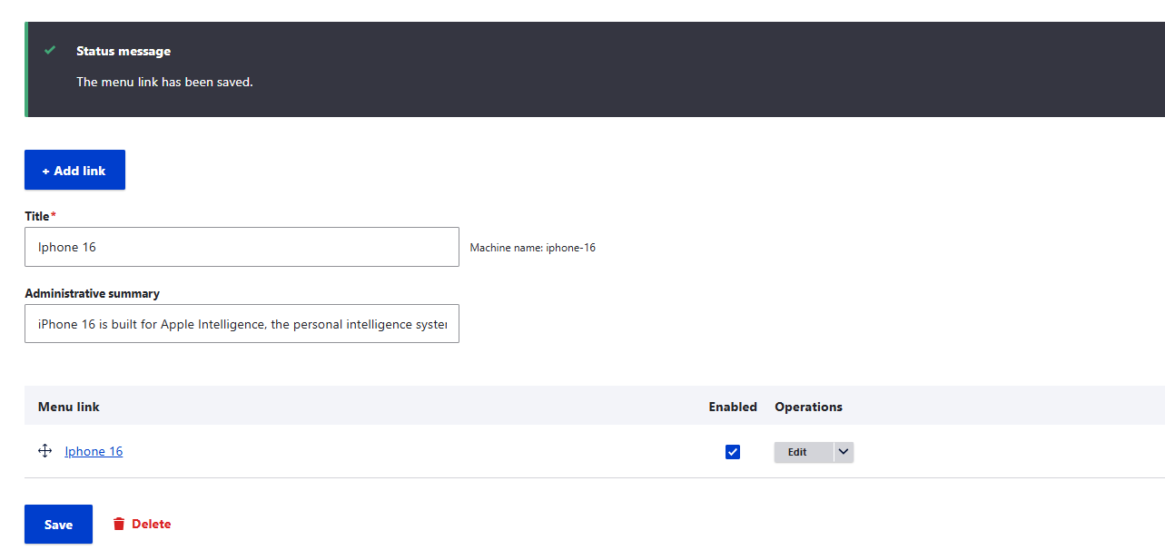

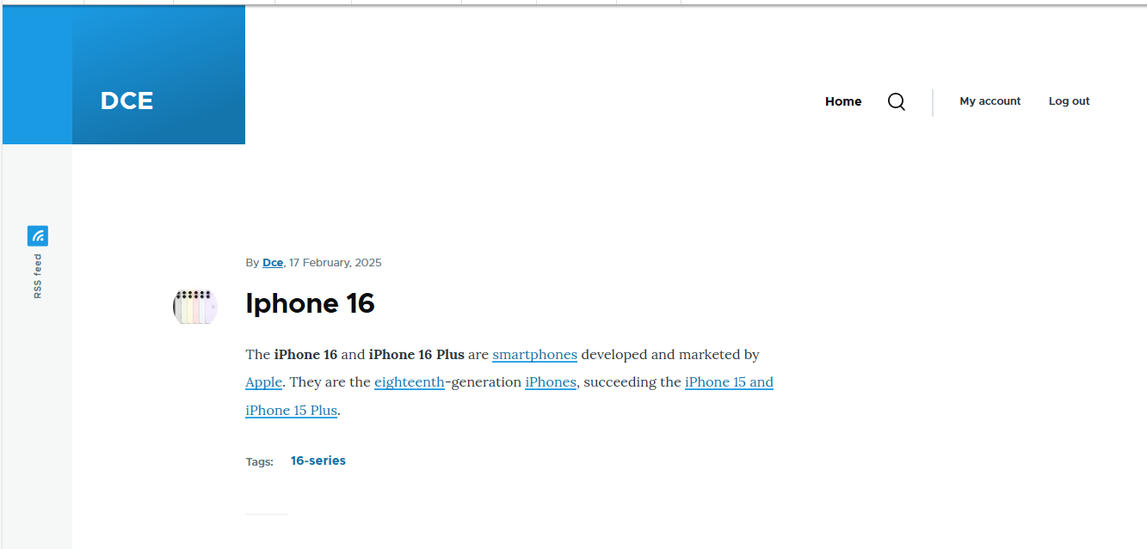



**RESULT:**

Thus article and menu are created successfully using Drupal Tool.